WEBD 1000 CSS FLUID Layouts & FLOATING

**Website Development**

# Instructions

**You will complete the following steps in class and post the file(s) that you are asked to produce to the Brightspace dropbox for today’s in-class activity. If you need help with any step, ask the instructor.**

# Part A:

1. Read the following tutorial on floating: [CSS Tricks: All About Floats](https://css-tricks.com/all-about-floats/)
2. Now, go to the [Mozilla: Learn CSS - Floats Skills](https://developer.mozilla.org/en-US/docs/Learn/CSS/CSS_layout/Floats_skills) site.
   1. Complete the 3 steps (i.e. **Float one**, **Float two**, and **Float three** interactive examples).
   2. Take screenshots showing successful completion of all the tasks and upload them with the Part B files of this Exercise when complete.

# Part B:

1. In the BrightSpace dropbox for today’s activity, you have been provided with a ZIP file containing some file resources for a web page:
   1. An HTML page called *lawncare.html*
   2. A CSS file called *styles.css*.
   3. Images called *grass_seamless_pattern.jpg*, *mowercycle.jpeg*, and *weeding_success.jpeg.*
2. Copy the site to an Exercise 7 folder in your preferred folder location for this class.
3. Open the site files in NotePad++ (or the editor of your choice):
   1. Preview the *lawncare.html* file in a browser. Your page should look like the BEFORE image on the following page.
   2. Take a look at the *styles.css* file that you have been provided and try to make sense of the CSS rules that are used there. A couple of them are advanced ones that we have not seen yet.
   3. Add a CSS page to the website called *layout_styles.css* and properly link it into the HTML page. Do **NOT** delete the existing *styles.css* file or remove its link from the HTML.
   4. You will make the following additions to the new *layout_styles.css* page:
      1. Set the charset of the CSS file to “UTF-8” appropriately.
      2. Add a comment marking yourself as the author and with today’s date (in the CSS file). The comment should also say that this is the layout style page for Acme Lawn Care.
      3. Set the minimum width of the page body to 800 pixels.
      4. Align the headings in the center of the page.
      5. Make sure all images in all articles are floated to the right.
      6. For the article with an ID of **mowing**:
         1. Make sure that it floats to the left
         2. Give it a width of 40 percent.
         3. Set left and right margins of 4 percent.
         4. Set a bottom margin of 20 pixels.
         5. Set its height to 350 pixels.
      7. For the article with an ID of **weeding**:
         1. Make sure that it floats to the left
         2. Give it a width of 40 percent.
         3. Set right margin of 4 percent.
         4. Set a bottom margin of 20 pixels.
         5. Set its height to 350 pixels.
      8. For the article with an ID of **landscaping**:
         1. **Make sure** that it does **not** float like the previous articles.
         2. Give it a width of 88 percent.
         3. Set left margin of 4 percent.
         4. Set top and bottom margins of 20 pixels.
      9. Align the footer text in the center of the page.
   5. **See the AFTER (Half Screen) and AFTER (Narrower Screen) examples on the next page(S) for an idea of what the Webpage should now look like. NOTE: That it will look a bit different at Full Screen on the Wide Monitors as we do not quite have the content to fill the article sizes at that point so they will be a little distorted. We will see how to handle such situations later on.**
4. Once the above Step is completed, validate the ***layout_styles.css*** file using the W3C CSS validation website. Take a screenshot showing successful validation.
5. Post a ZIP file containing both the **Screenshots** from Part A and **the whole website from Part B** plus **screenshot of successful validation** to the Brightspace Dropbox for the seventh in-class exercise in order to obtain credit for completing it.
6. That’s it.

# Highly Recommended

**There is no need to submit the results of this part of the activity and it will not be graded. However, it will be excellent practice for the upcoming assignment. If you need help with any step, ask the instructor.**

1. Complete the Tutorial 3 – Session 1 practice steps from the Textbook. The practice tutorial steps are in light brown or beige boxes within the chapters of the textbook. In this case the tutorial steps begin on page **HTML179** (Section 3-3) and conclude on page **HTML203** (Section 3-6c) for this Session.
2. Once the above Step is completed, validate the following files using the W3C CSS validation website:
   1. *pc_reset.css*
   2. *pc_home.css*

# Before:

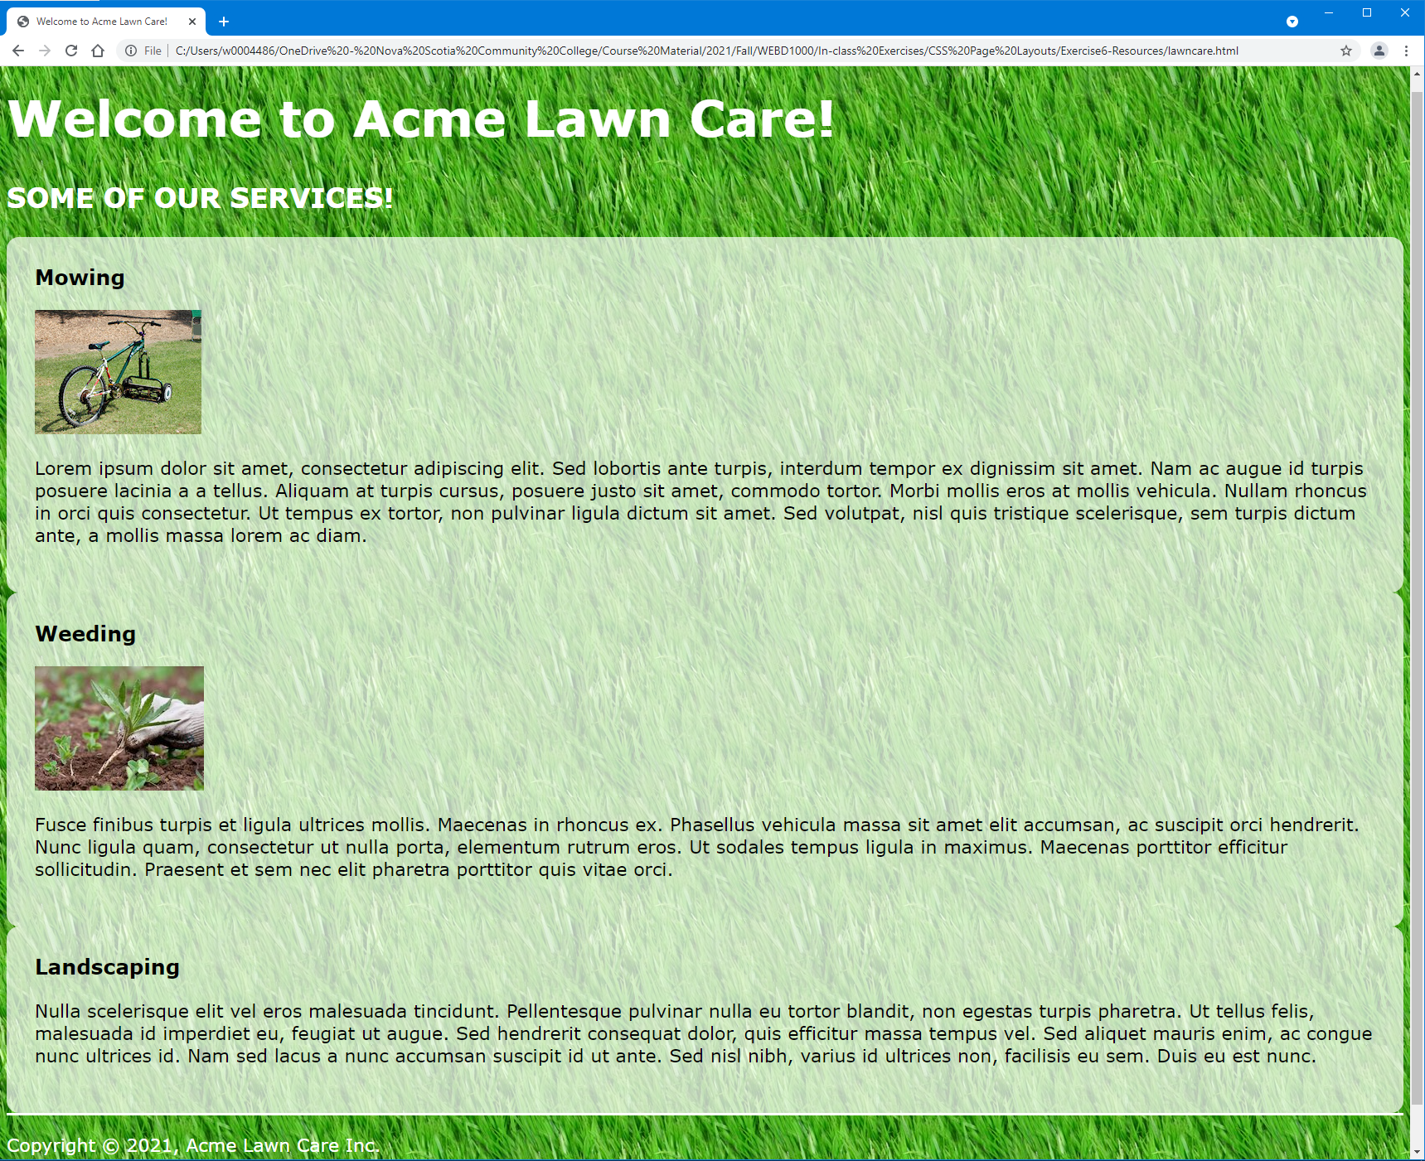

# After (Half-Screen Size on Our Wide Monitors):

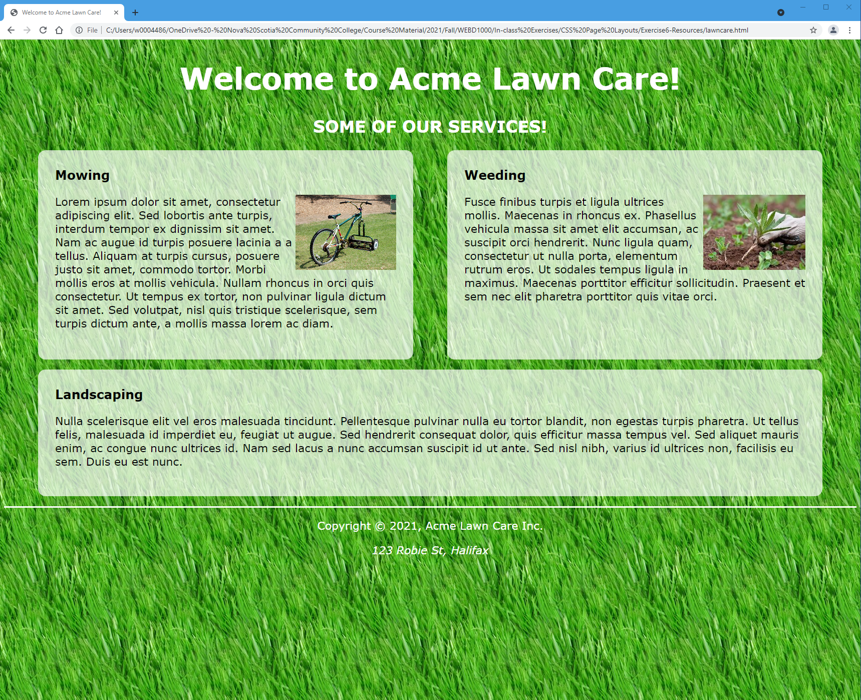

# After (Narrower Screen):

